IBM HR Analytics Dashboard
Project Overview
The IBM HR Analytics Dashboard is an interactive Power BI dashboard developed to analyse employee attrition and workforce trends. The dashboard provides HR managers with insights into employee turnover, job satisfaction, overtime, departmental performance, work-life balance, and demographic distribution. By analysing these factors, organizations can identify the major reasons behind employee attrition and make informed decisions to improve employee retention.
Problem Statement
Employee attrition is one of the major challenges faced by organizations. Losing experienced employees increases recruitment costs, training expenses, and decreases productivity. HR departments require an effective way to identify the key factors contributing to employee turnover. This dashboard aims to provide meaningful insights into employee attrition using historical HR data.
Objectives
Our project objectives are:
- Analyse the overall employee attrition.
- Measure the employee attrition rate.
- Study the impact of overtime on attrition.
- Compare attrition across different departments.
- Analyse employee distribution by gender.
- Study job satisfaction levels.
- Analyse work-life balance ratings.
- Examine employee distribution across education fields.
- Provide HR with actionable insights for improving employee retention.
Dataset Description
Dataset Name
IBM HR Analytics Employee Attrition Dataset
Source
IBM Sample HR Analytics Dataset
Dataset Size
- Total Records: 1470
- Total Columns: 35
After cleaning:
- Records: 1470
- Columns: 31
Columns removed:
- Employee Count
- Employee Number
- Over18
- Standard Hours

KPI ANALYSIS

KPI 1: Total Employees (1.47K)

Why did we create this KPI?
To know the total workforce in the organization. It serves as the baseline for all other HR metrics.

What does it show?
The company has 1,470 employees.

Business Insight
This represents the total employee population used for attrition analysis.

HR Recommendation
HR can use this number to compare workforce size over different years and monitor organizational growth.
KPI 2: Employees Left (237)
Why?
To know how many employees resigned or left the organization.
What does it show?
A total of 237 employees have left.
Business Insight
A significant number of employees have exited the organization, which may increase recruitment and training costs.
HR Recommendation
Investigate the common characteristics of employees who left and implement retention strategies.
KPI 3: Attrition Rate (16.12%)
Why?
Attrition rate is one of the most important HR performance indicators.
What does it show?
Approximately 16 out of every 100 employees have left the company.
Business Insight
A 16.12% attrition rate indicates that employee turnover exists and should be monitored to identify underlying causes.
HR Recommendation
Focus on improving employee engagement, career development, compensation, and work-life balance to reduce turnover.
KPI 4: Average Age (37 Years)
Why?
To understand the overall age profile of the workforce.
What does it show?
The average employee age is 37 years.
Business Insight
The workforce is largely composed of mid-career professionals, indicating a balance of experience and productivity.
HR Recommendation
Provide career advancement opportunities and leadership development programs to retain experienced employees.
KPI 5: Average Monthly Income (6.50K)
Why?
Salary is an important factor that can influence employee satisfaction and retention.
What does it show?
The average monthly income of employees is approximately 6.5K (based on the dataset's currency).
Business Insight
This provides a benchmark for comparing compensation across departments and job roles.
HR Recommendation
Regularly review salary structures and ensure competitive compensation to improve employee retention.

CHART-WISE BUSINESS ANALYSIS.
Chart 1: Employee Attrition Count
Why did we create this chart?
To compare the number of employees who stayed with the company versus those who left.
What does it show?
- 1,233 employees stayed with the company.
- 237 employees left the company.

Business Insight
The majority of employees remain with the organization. However, the 237 employees who left contribute to an overall attrition rate of 16.12%, indicating that employee turnover is present and should be monitored.
HR Recommendation
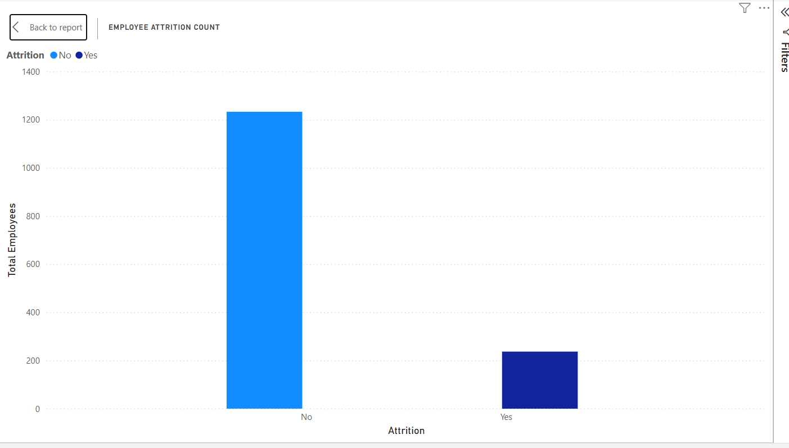
HR should identify the common characteristics of employees who left and implement retention initiatives

Chart 2: Overtime vs Attrition
Why did we create this chart?
To understand whether working overtime is associated with employee attrition.
What does it show?
Employees who work overtime have a noticeably higher proportion of attrition compared to those who do not work overtime.
Business Insight
Overtime appears to be associated with a greater likelihood of employees leaving the organization. This may indicate increased workload, stress, or reduced work-life balance.
HR Recommendation
- Monitor overtime hours regularly.
- Ensure fair workload distribution.
- Encourage managers to prevent excessive overtime and support employee well-being.
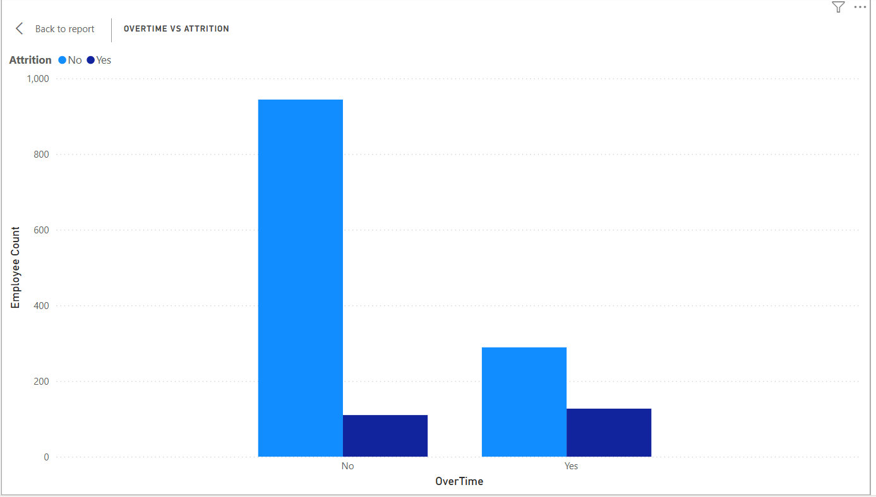
Chart 3: Gender Distribution
Why did we create this chart?
To understand the composition of the workforce by gender.
What does it show?
- 60% Male (882 employees)
- 40% Female (588 employees)
Business Insight
The organization has a higher proportion of male employees than female employees. This chart describes workforce composition and does not by itself indicate differences in attrition.
HR Recommendation
Continue promoting diversity and inclusion initiatives while ensuring equal opportunities for all employees.
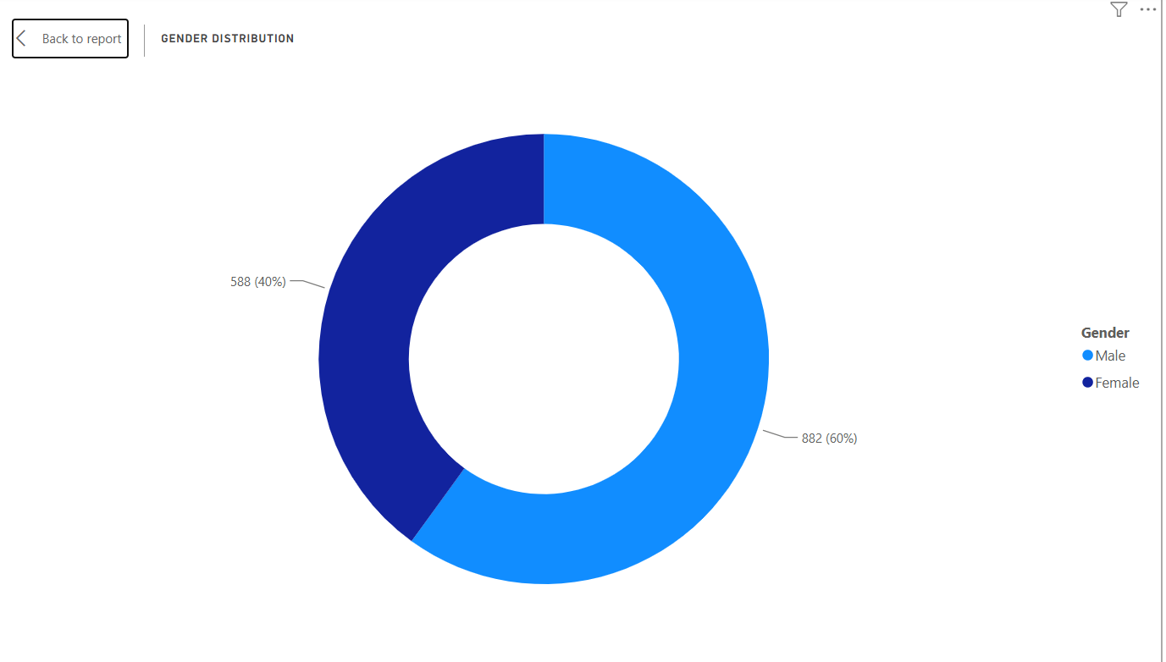

Chart 4: Department vs Attrition
Why did we create this chart?
To compare employee attrition across departments.
What does it show?
Research & Development has the largest workforce and also the highest number of employees leaving. Sales follows, while Human Resources has the fewest employees and the lowest number of employees leaving.
Business Insight
Since Research & Development employs the most people, it naturally records more attrition in absolute numbers. HR should compare attrition rates (not just counts) across departments before concluding that one department has a bigger retention problem.
HR Recommendation
Analyse department-specific factors such as workload, career growth, and employee satisfaction, particularly in larger departments like Research & Development and Sales.
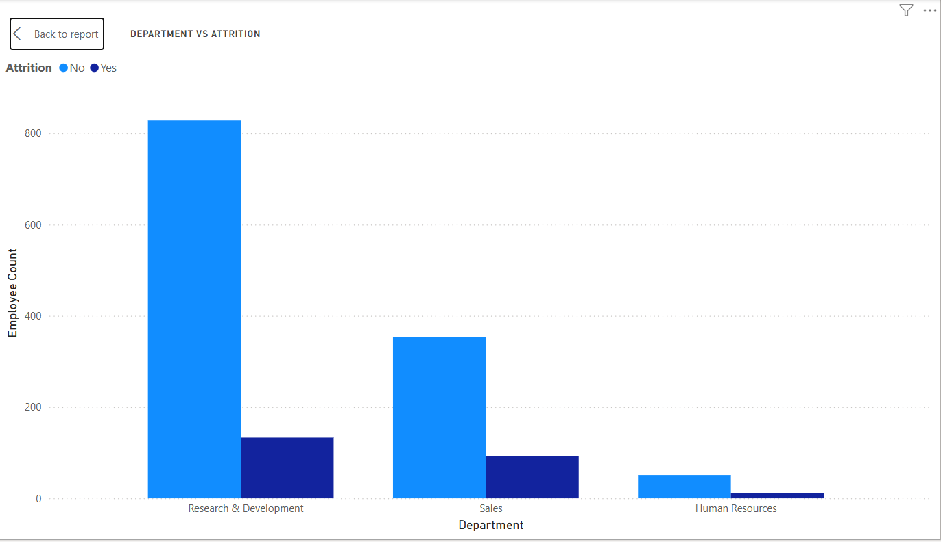
Chart 5: Work-Life Balance vs Attrition
Why did we create this chart?
To understand whether employees' work-life balance is related to attrition.
What does it show?
Employees are rated on a work-life balance scale from 1 (Poor) to 4 (Excellent).
Most employees have a rating of 3, while fewer employees have ratings of 1 and 4.
Employees who left are present across all ratings, but they are more noticeable in ratings 2 and 3 because these groups contain more employees.
Business Insight
The organization generally maintains a moderate to good work-life balance. However, employee attrition still exists, indicating that work-life balance alone may not fully explain why employees leave.
HR Recommendation
- Continue promoting flexible work policies.
- Conduct employee feedback surveys to identify additional factors affecting retention.
- Support employees in maintaining a healthy work-life balance.
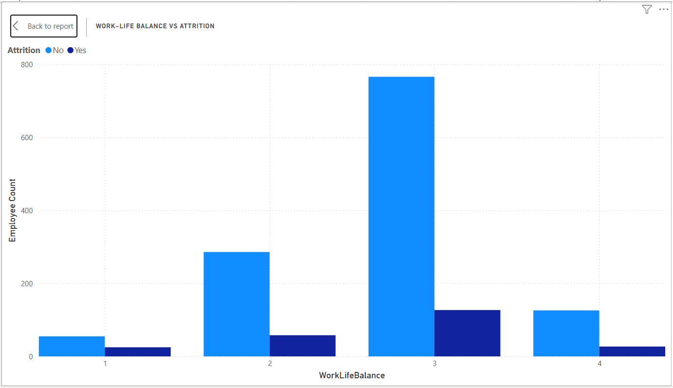
Chart 6: Job Satisfaction vs Attrition
Why did we create this chart?
To examine whether employee job satisfaction influences attrition.
What does it show?
Employees are grouped into satisfaction levels ranging from 1 (Low) to 4 (High).
Most employes report satisfaction levels 3 and 4, while fewer employees fall into levels 1 and 2.
Employees who left are distributed across all satisfaction levels.
Business Insight
The company has a generally satisfied workforce. However, attrition occurs even among employees with higher satisfaction levels, suggesting that factors such as salary, career growth, overtime, or work environment may also contribute to employee turnover.
HR Recommendation
- Regularly monitor employee satisfaction.
- Improve career development opportunities.
- Strengthen employee engagement programs.
- Investigate additional reasons behind employee resignations.
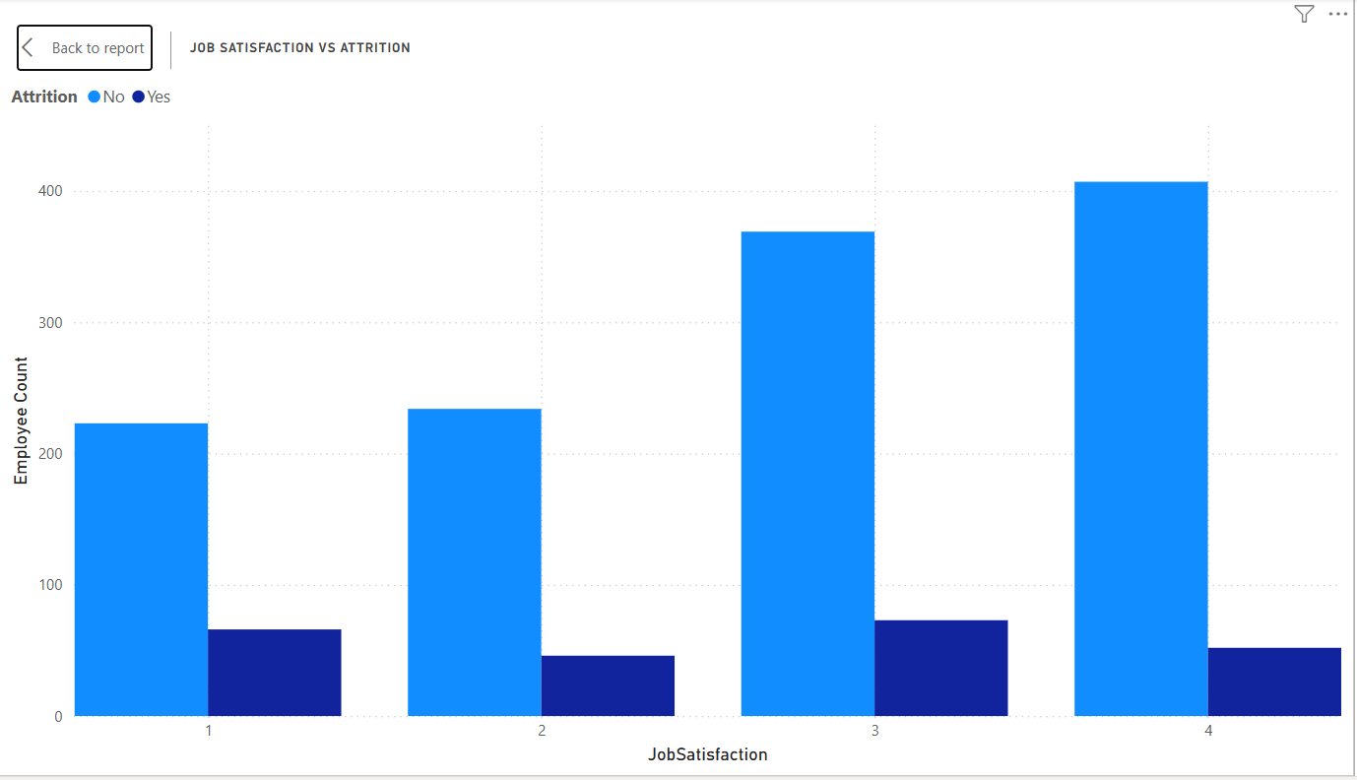
Chart 7: Job Role vs Attrition
Why did we create this chart?
To compare employee distribution and attrition across different job roles.
What does it show?
The largest employee populations are found in roles such as:
- Sales Executive
- Research Scientist
- Laboratory Technician
These roles also show the highest number of employees leaving.
Business Insight
Higher attrition counts are observed in job roles with larger employee populations. To identify which roles face the greatest retention challenge, HR should compare attrition rates by role rather than raw counts.
HR Recommendation
- Identify high-risk job roles.
- Improve career progression and training opportunities.
- Review workload and compensation in roles with consistently higher attrition.
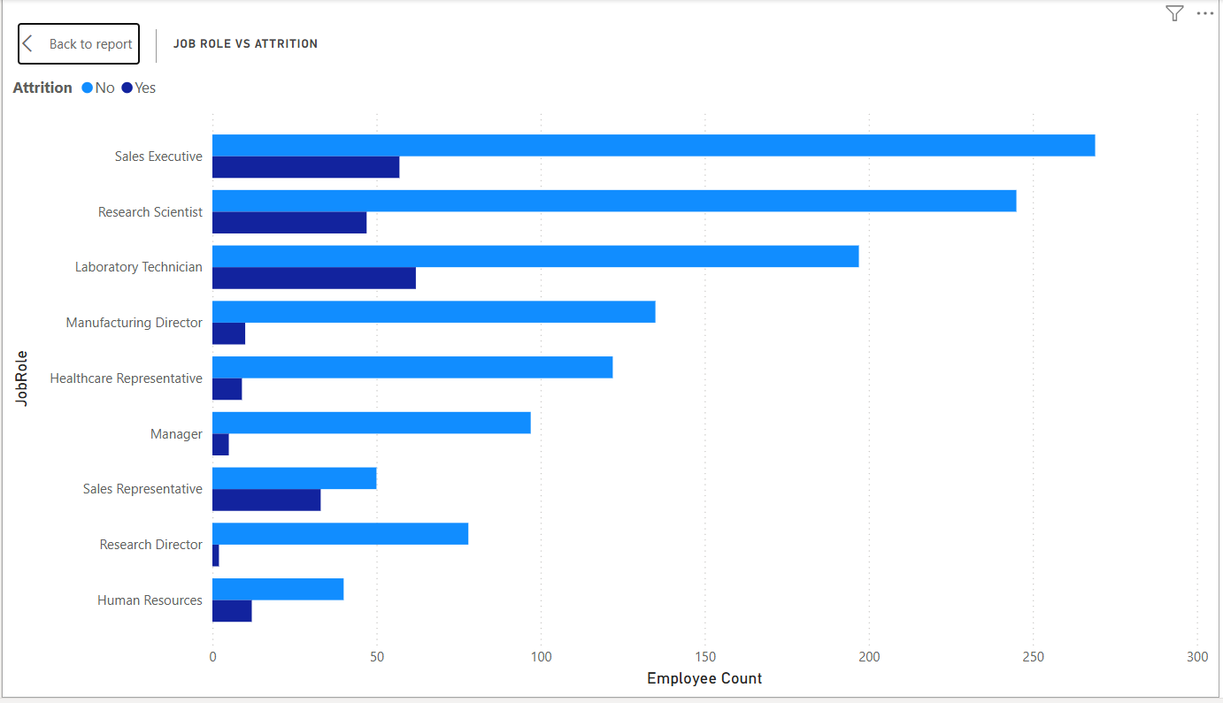
Chart 8: Education Field Distribution
Why did we create this chart?
To understand the educational background of employees.
What does it show?
The majority of employees come from:
- Life Sciences
- Medical
while fewer employees belong to:
- Marketing
- Technical Degree
- Other
- Human Resources
Business Insight
The workforce is primarily composed of employees from Life Sciences and Medical backgrounds. This likely reflects the nature of the organization's workforce and hiring patterns.
HR Recommendation
Maintain a balanced recruitment strategy while ensuring employees from all educational backgrounds receive equal opportunities for growth and development.
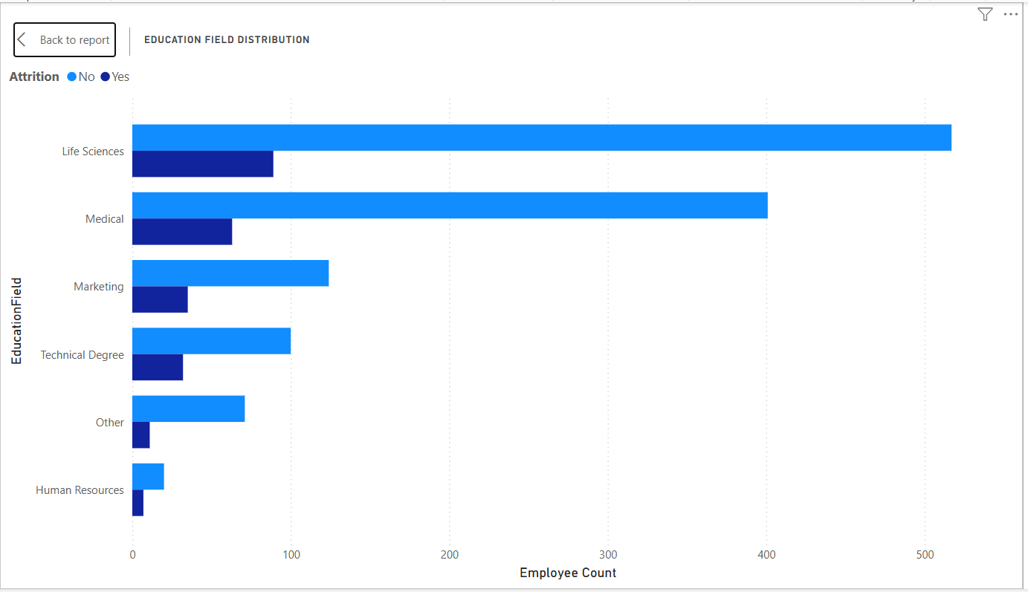

Tools & Technologies
- Pandas : Used for data loading, preprocessing, and cleaning.
- Matplotlib : Used to create data visualizations.
- Seaborn : Used to create statistical data visualizations.
- Power BI : Used to build an interactive HR analytics dashboard.
- Jupyter Notebook : Used to develop and execute the Python analysis.

Python Workflow
- Imported Dataset
- Data Cleaning
- Missing Value Analysis
- Removed Constant Columns
- Statistical Summary
- Correlation Analysis
- Data Visualization
- Exported Clean Dataset
Overall Dashboard Findings
Based on the dashboard analysis:
- The organization has 1,470 employees, with 237 employees leaving, resulting in an attrition rate of 16.12%.
- Among employees in this dataset, those who worked overtime included more employees who left than the group that did not work overtime. Further analysis using attrition rates would help confirm the strength of this relationship.
- The workforce consists of 60% male and 40% female employees.
- Research & Development has the largest workforce and the highest number of employees leaving in absolute terms.
- Most employees report moderate to high job satisfaction and good work-life balance, indicating that attrition is likely influenced by multiple factors rather than a single issue.
- The workforce is concentrated in Life Sciences and Medical educational backgrounds.
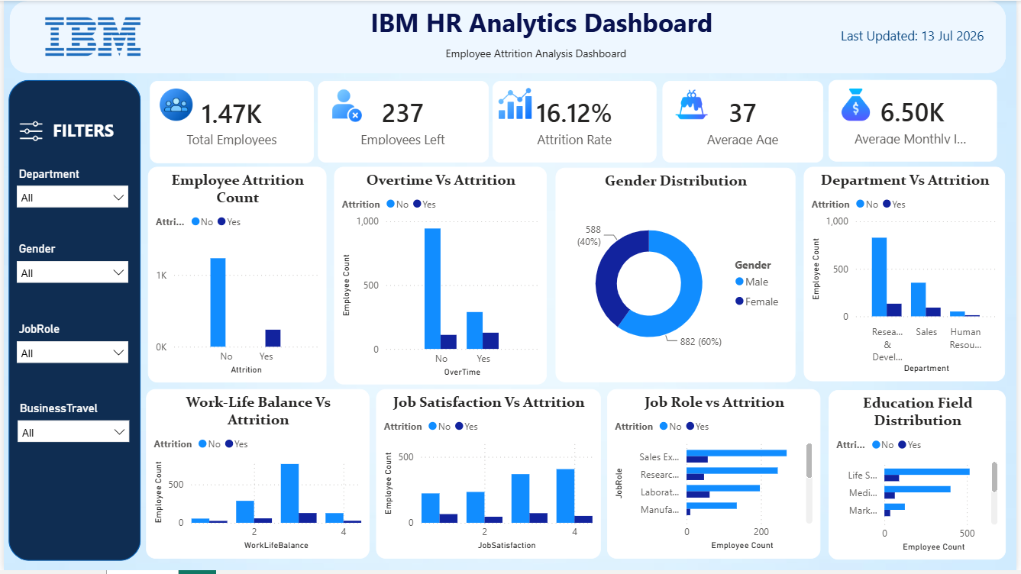
Business Recommendations
Based on the analysis, the organization should:
- Monitor employees who frequently work overtime and implement workload management strategies.
- Conduct regular employee satisfaction and engagement surveys to identify retention issues early.
- Develop career growth and learning opportunities, especially in departments and job roles with higher attrition.
- Review compensation and benefits periodically to remain competitive.
- Continue supporting employee well-being through work-life balance initiatives.
- Use predictive analytics in future studies to identify employees who may be at higher risk of leaving.

Conclusion
This dashboard provides a comprehensive overview of employee attrition and workforce characteristics using the IBM HR Analytics dataset. Through interactive visualizations and key performance indicators, it enables HR teams to monitor attrition trends, analyze employee demographics, and identify potential factors influencing employee turnover. The insights generated from this dashboard can support data-driven decision-making and help organizations develop effective employee retention strategies.

